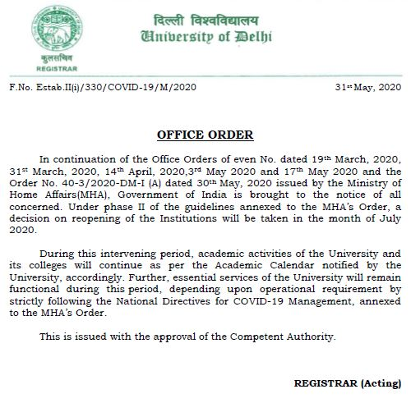
UCMS
No. MC/CCS/COVID-19/2020 Dated : 01.06.2020

The above Office Order is endorsed for circulation among all teaching and non-teaching staff members of the College. Being a Medical College, UCMS is handling COVID-19 pandemic, all the essential/emergency/patient-care Services shall remain operational and must be attended. All the teaching and non-teaching staff shall strictly be available on telephone/email/WhatsApp/SMS etc. The non-teaching staff members must ensure to attend the office on the direction(s) of concerned HOD/Section In-charges, so that official work/patient care may not be suffered in any circumstances.

During this period online teaching-learning process will continue.

It is further informed that leave of all medical, para-medical and nursing staff stands cancelled till further orders, for the purpose of prevention of outbreak of epidemic disease namely COVID-19.

Sd/-
PRINCIPAL
Copy for information and n.a. to:

- All HODs/ARs/SOs/Incharges of Sections/Co-coordinators etc., of UCMS.
- Prof. Arun Sharma HOD, BMI with the request to upload it on the COLLEGE WEBSITE.

